DESIGN AND ANALYSIS OF ALGORITHM
NAME: NIVASINI VM
REG NO : 192511356
CO 4 -ASSESMENT TOOL 3
Q26. Travelling Salesperson vs Bellman-Ford (DP Comparison)
Solve TSP using DP and shortest path using Bellman-Ford. Compare complexity and problem nature. Analyze exponential vs polynomial time behavior. Evaluate scalability challenges. Discuss applicability in routing problems. Generate insights on DP limitations.
Answer
Introduction
The Travelling Salesperson Problem (TSP) and the Bellman-Ford algorithm are both important graph-based techniques used in routing and optimization. However, they solve different types of problems. TSP finds the minimum-cost tour that visits every city exactly once and returns to the starting city, whereas Bellman-Ford finds the shortest path from a source vertex to all other vertices, even when some edges have negative weights.
1. Travelling Salesperson Problem Using Dynamic Programming
Suppose there are n cities and a cost matrix cost[i][j] representing the travel cost from city i to city j.
The objective is to start from a particular city, visit every city exactly once, return to the starting city, and minimize the total travel cost.
DP State
Let dp[S][i] represent the minimum cost of starting from city 0, visiting all cities in set S, and ending at city i.
The recurrence relation is:
dp[S][i] = min(dp[S − {i}][j] + cost[j][i])
where j belongs to S and j is not equal to i.
Finally, the minimum tour cost is obtained by adding the cost of returning to the starting city.
Python Program for TSP Using DP
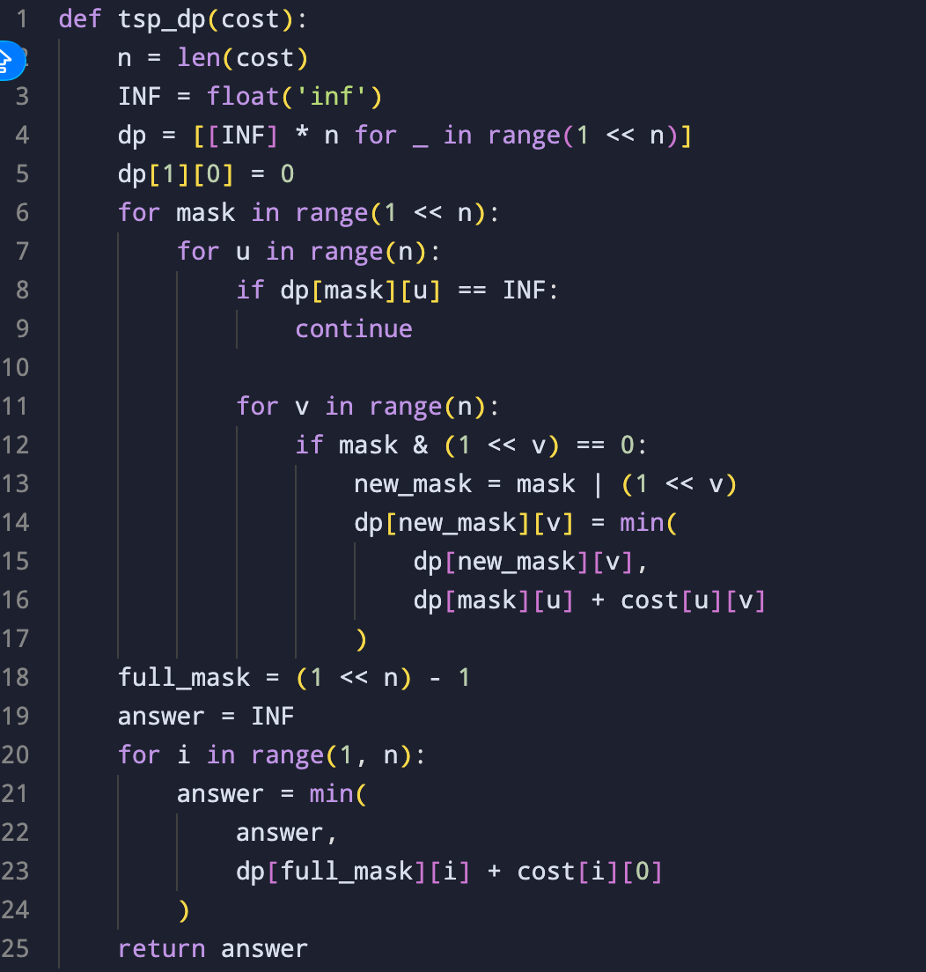

Output
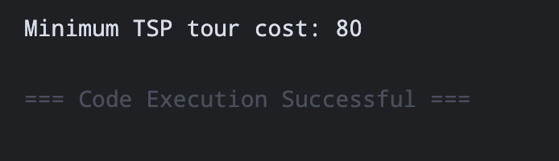
One minimum tour is 0 → 1 → 3 → 2 → 0.
Total cost = 10 + 25 + 30 + 15 = 80.
2. Shortest Path Using Bellman-Ford
Bellman-Ford calculates the shortest distance from a source vertex to every other vertex. It repeatedly relaxes every edge. For an edge u → v with weight w, the relaxation operation is:
dist[v] = min(dist[v], dist[u] + w)
The process is repeated V − 1 times. An important advantage of Bellman-Ford is that it can handle negative edge weights and detect negative-weight cycles.

Python Program for Bellman-Ford
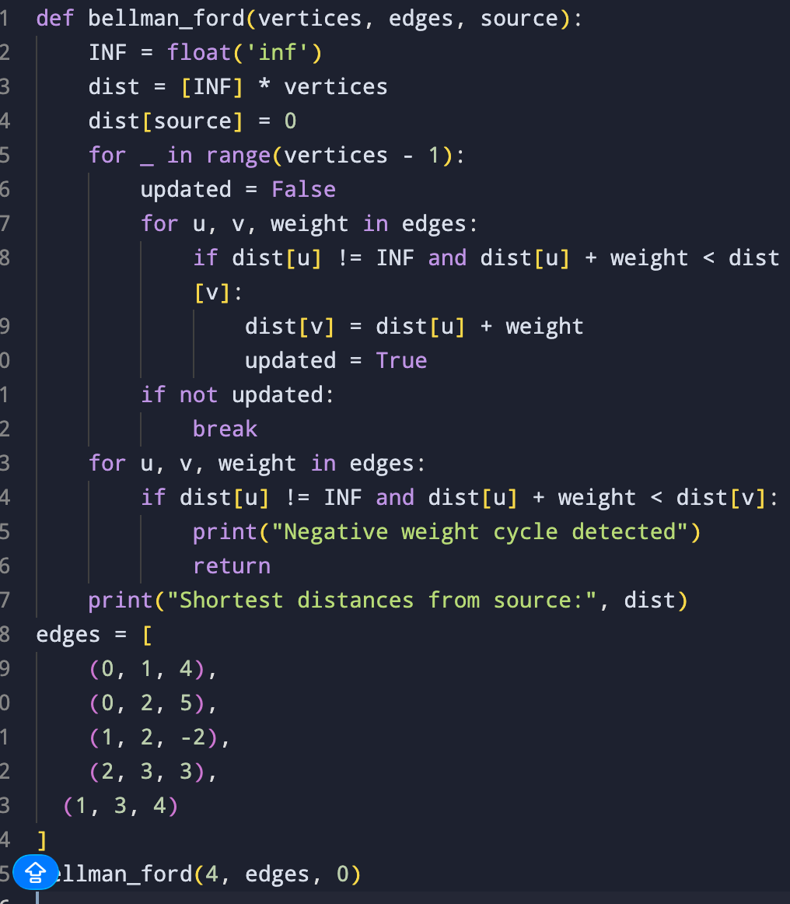

Output
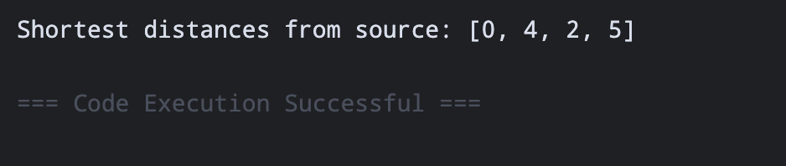
Therefore, the shortest distance from vertex 0 to vertex 3 is 5.

3. Complexity Comparison
Feature | TSP using DP | Bellman-Ford
Problem type | Optimization | Shortest path
Main objective | Minimum complete tour | Minimum path from source
Approach | Dynamic Programming | Edge relaxation
Time complexity | O(n² 2ⁿ) | O(VE)
Space complexity | O(n 2ⁿ) | O(V)
Negative edges | Not the main focus | Supported
Negative cycle detection | No | Yes
Exact solution | Yes | Yes
Scalability | Poor for large n | Better
Problem difficulty | NP-hard | Polynomial-time
4. Exponential vs Polynomial Time
The major difference between the two algorithms is their growth rate.
TSP using Dynamic Programming has a time complexity of O(n² 2ⁿ). The 2ⁿ term grows very quickly as the number of cities increases.
For example, 2¹⁰ = 1,024, 2²⁰ = 1,048,576, and 2³⁰ is approximately 1.07 billion. Therefore, even though DP is much better than checking all n! possible tours, the exact solution becomes expensive for large numbers of cities.
Bellman-Ford has a time complexity of O(VE), which is polynomial. Therefore, increasing the number of vertices and edges causes a slower growth compared with the exponential TSP DP solution.
5. Scalability Challenges
The main limitation of TSP DP is its computation and memory requirement. The DP table contains approximately n × 2ⁿ states. Because of this, the algorithm becomes impractical for large numbers of cities.
For large real-world routing problems, practical methods such as approximation algorithms, heuristics, genetic algorithms, Branch and Bound, and local search are often used instead of exact TSP DP.
Bellman-Ford scales better because its complexity is polynomial. However, for very large dense graphs, O(VE) can still be expensive. When there are no negative edge weights, algorithms such as Dijkstra can often be faster.
6. Applicability in Routing Problems
TSP is useful when the objective is to determine the best complete route. Examples include delivery vehicle routing, school bus route planning, courier services, robot movement, salesperson travel planning, and inspection routes.
Bellman-Ford is useful when the objective is to find the shortest path from one location to other locations. Examples include network routing, transportation networks, communication systems, and routing situations involving negative edge weights.
7. Critical Evaluation
TSP using Dynamic Programming provides an exact solution and is significantly better than checking all n! possible tours. Dynamic Programming avoids recomputing the same subproblems and reduces the complexity to approximately O(n² 2ⁿ).
However, Dynamic Programming does not remove the fundamental difficulty of TSP. The exponential 2ⁿ factor still makes the algorithm unsuitable for large instances.
Bellman-Ford has polynomial complexity and can handle negative edge weights. Its ability to detect negative cycles is another important advantage. Its main disadvantage is that it can be slower than specialized shortest-path algorithms when their assumptions are satisfied.
8. Insights on Dynamic Programming Limitations
• Dynamic Programming does not always produce polynomial-time algorithms. TSP shows that DP can reduce computation substantially while still having exponential complexity.
• The problem structure determines scalability. TSP requires considering combinations of visited cities, resulting in 2ⁿ states.
• Bellman-Ford has better scalability because its O(VE) complexity is polynomial and therefore more suitable for larger graphs.
• Exact optimization can be expensive because TSP requires finding the globally optimal tour.
• Different routing problems require different algorithms. TSP focuses on completing a tour through all required locations, while Bellman-Ford focuses on shortest paths.
Conclusion
TSP using Dynamic Programming and Bellman-Ford illustrate two different uses of algorithmic optimization. TSP DP provides an exact solution with a complexity of O(n² 2ⁿ), but its exponential nature creates serious scalability limitations. Bellman-Ford provides shortest paths in polynomial time O(VE), supports negative edge weights, and can detect negative cycles.
Therefore, TSP DP is appropriate for small or moderate-sized route-optimization problems where an exact tour is required, whereas Bellman-Ford is more suitable for shortest-path and network-routing problems. The main lesson is that Dynamic Programming can greatly improve an algorithm without necessarily making the underlying problem efficiently scalable.

